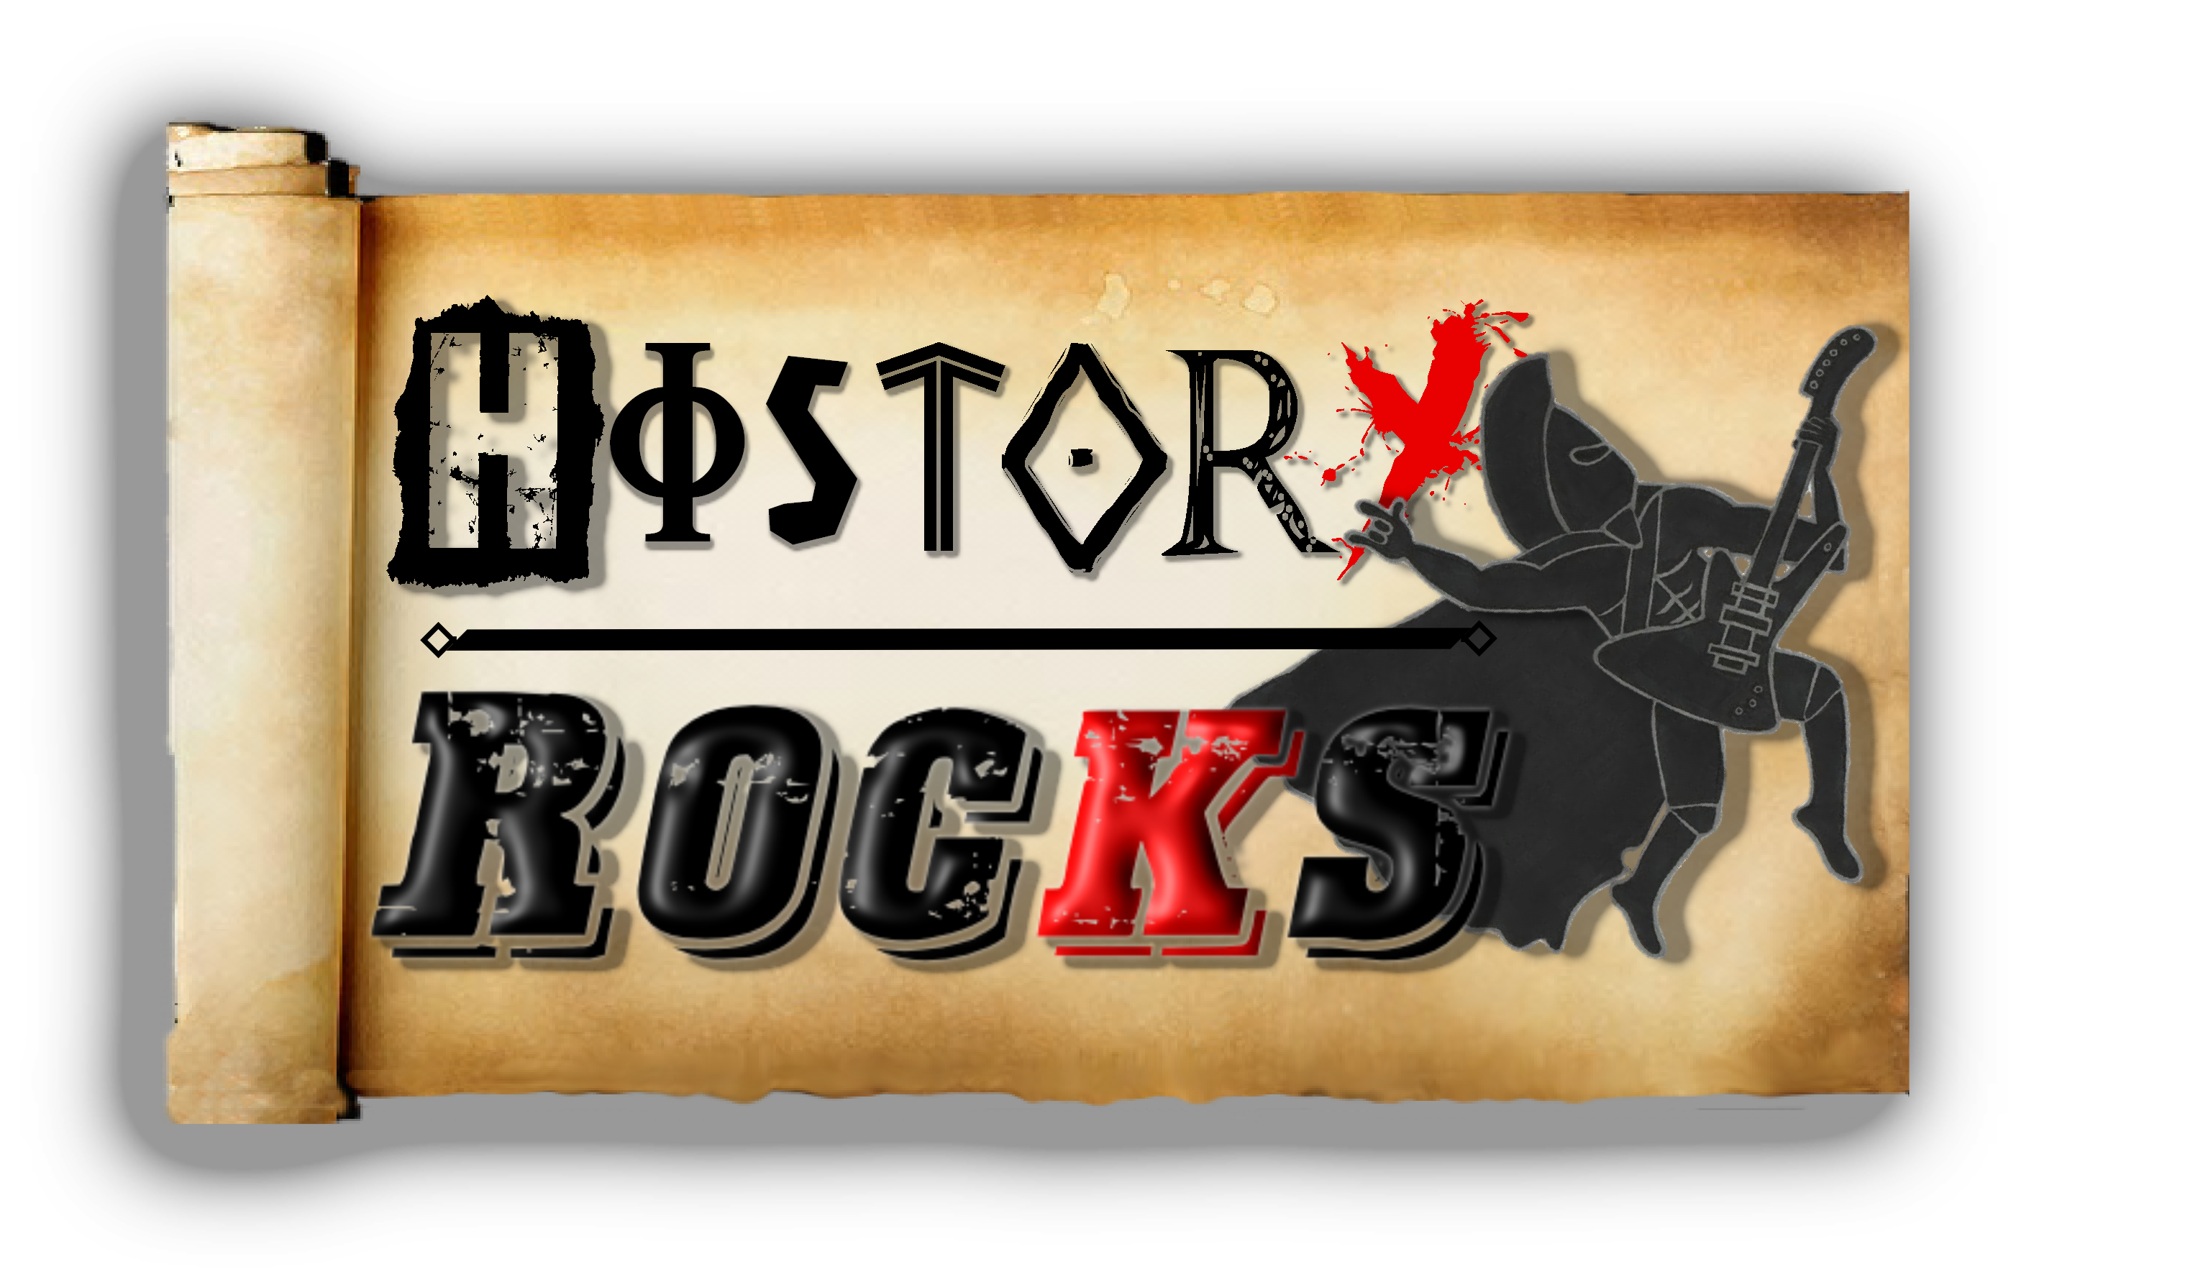
Vikings – Viking Boast Battle
The most you ever got
Was when you visited France
You got some cheese, you got some wine
You got some stinky pants!
You’re nothin’ but a fake
And now you’re targeting monks
Little, old baldy men
Defenceless little chumps

So? Look at you
You’re taking a bribe
The kings all pay you money
For you to go and hide

It looks like we have met our match
No loss in pride
We better call on Odin
For him to decide, bro!

You know who it is
Yeah you all know me
I’m the V-I-K-I-N-G
Got my sharpened axe
Got my treasured blade
No time to relax
‘Cos you’re gonna’ be slayed
Like the other 7 men I had to annihilate
I cut ‘em and I gut ‘em and decapitate
While you’ve been chillin’
I’ve been killin’
And I’m keepin’ a tab
The best thing that you ever did
Was killin’ a crab, what?

Oh, what’s this?
You’re a puny little boy
Your sword’s about as sharp
As a wooden toy
Take it from me kid listen
If you’re wanting to boast
You better take some lessons
From the one who’s killed the most, oh!

I’ve travelled the world
And I’ve travelled the seas
I’ve raided and I’ve pillaged
So many countries
I’m losing track of all the gold
That I ever stole
I loaded up my pockets
And took it all home

