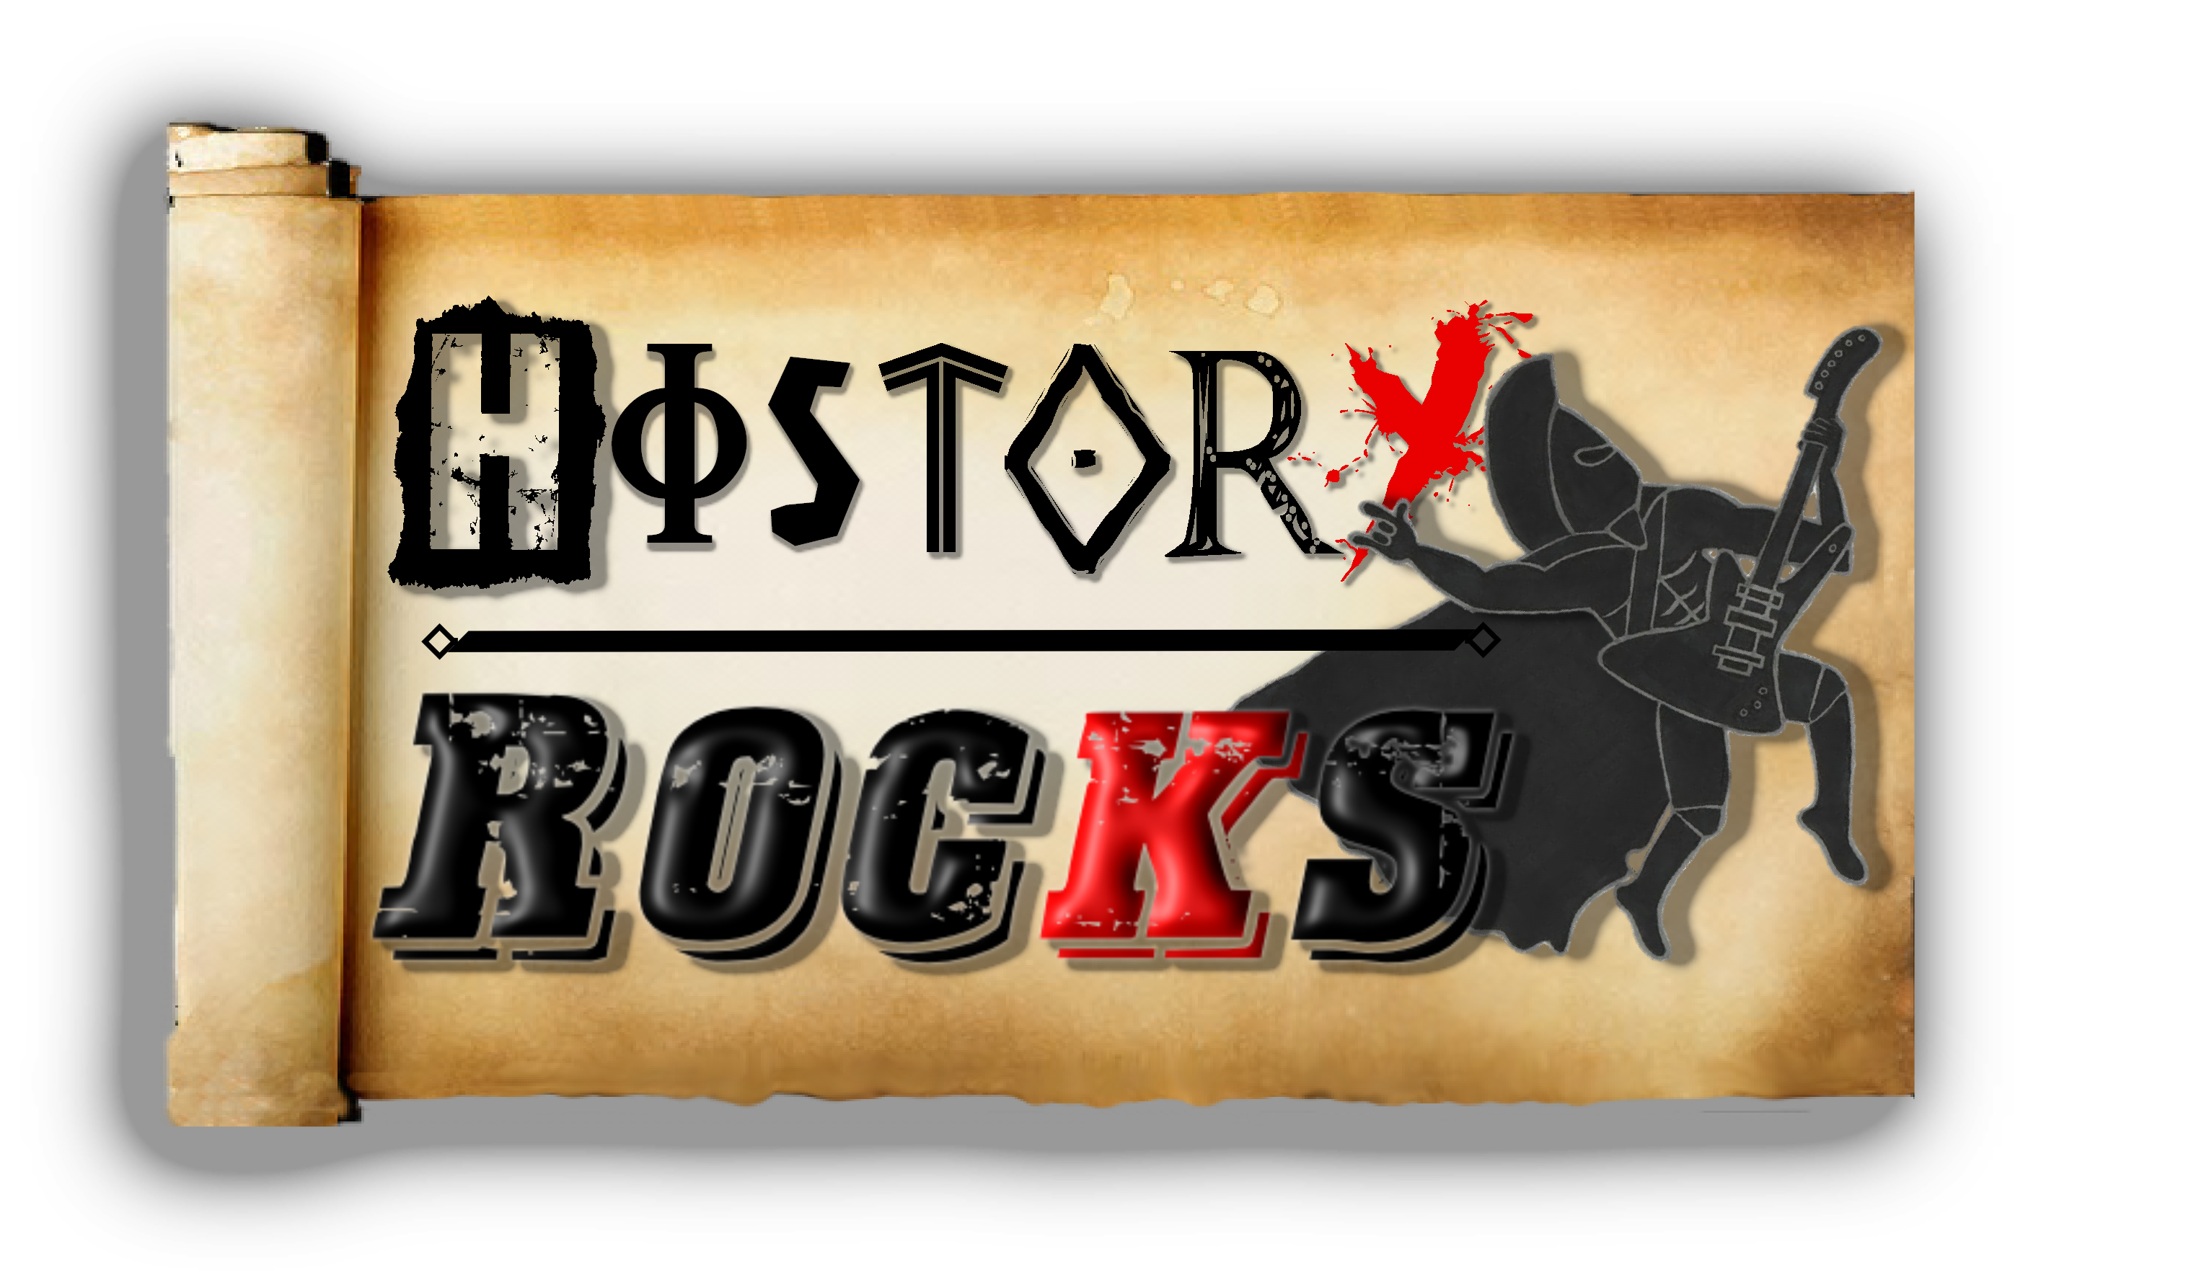
Stone Age – Stone Age Sucks!
Chorus

Hunt the mammoth
Kill the mammoth
Chase the tiger
Run from tiger
Go in the cave
Go out the cave
Start a fire
Put out the fire
Oh that's just how our day goes

Chorus
Welcome to the Stone Age
The rotten dirty bone age
Here we like to collect stones

Living in a damp cave
Don't see all the big rave
But this is our only home

Hunt the mammoth
Kill the mammoth
Oh that's just how our day goes

Chorus
The Stone Age rocks
Yeah the Stone Age rolls
But the Stone Age sucks
Cos all we've got is stones
We got stones, we got wood
We got bone, we got blood
But the mammoths try to take our homes

Hunting in the river
I'm feeling quite a shiver
Because we ain't got no clothes

Making rubbishy tools
And looking like complete fools
All we got is rock and bone

Chase the tiger
Run from tiger
Oh that's just how our day goes

Not today woolly mammoth!

