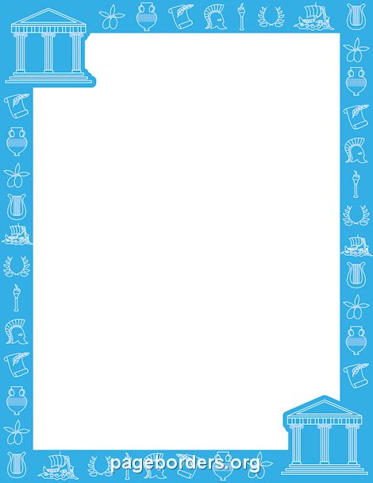

**ANCIENT GREECE QR Trail**

4. What is the name of an Ancient Greek poem?

Which technique means to ‘over-exaggerate’?

1. Which famous Battle has a name in the Olympics?

Name the soldier who ran back?

The word to find is:

1. Which mythical Greek creature was half horse?

Who did they follow?

Find and then scan the QR codes to write down the answer to each question. The first letter of each light blue answer will give you a word. When you have collected all of the answers, answer the dark blue questions for bonus points!

1. Which type of column had scrolls at the top?

Who copied the Corinthian column?

1. What is the name of an Ancient Greek dip?

Name 3 ingredients used to make it.

1. What was the name of the hill in Athens?

Whose helmet was visible from the sea?

1. Where was the Colossus found?

What was it and what happened to it?

1. Name the Greek invention that helped to move big items.

What is the name for map making?

1. What was the name of the Spartan Council?

How many Kings ruled Sparta at once?

1. Who was the Greek god of wine?

Name their special power against mortals.

Ionic

DEMOCRATIC

Dionysus

Centaur

Romans

Greek yogurt, cucumber, garlic, extra-virgin olive oil, white wine vinegar, fresh dill, table salt

Tzatziki

Athena

Acropolis

Statue that collapsed in an earthquake

Rhodes

Cartography

Crane

Hyperbole

Ode

Pheidippides

Marathon

Ephors

2

Drive them insane

Dionysus



**ANCIENT GREECE QR Trail**

4. What is the name of an Ancient Greek poem?

Which technique means to ‘over-exaggerate’?

1. Which famous Battle has a name in the Olympics?

Name the soldier who ran back?

The word to find is:

1. Which mythical Greek creature was half horse?

Who did they follow?

Find and then scan the QR codes to write down the answer to each question. The first letter of each light blue answer will give you a word. When you have collected all of the answers, answer the dark blue questions for bonus points!

1. Which type of column had scrolls at the top?

Who copied the Corinthian column?

1. What is the name of an Ancient Greek dip?

Name 3 ingredients used to make it.

1. What was the name of the hill in Athens?

Whose helmet was visible from the sea?

1. Where was the Colossus found?

What was it and what happened to it?

1. Name the Greek invention that helped to move big items.

What is the name for map making?

1. What was the name of the Spartan Council?

How many Kings ruled Sparta at once?

1. Who was the Greek god of wine?

Name their special power against mortals.