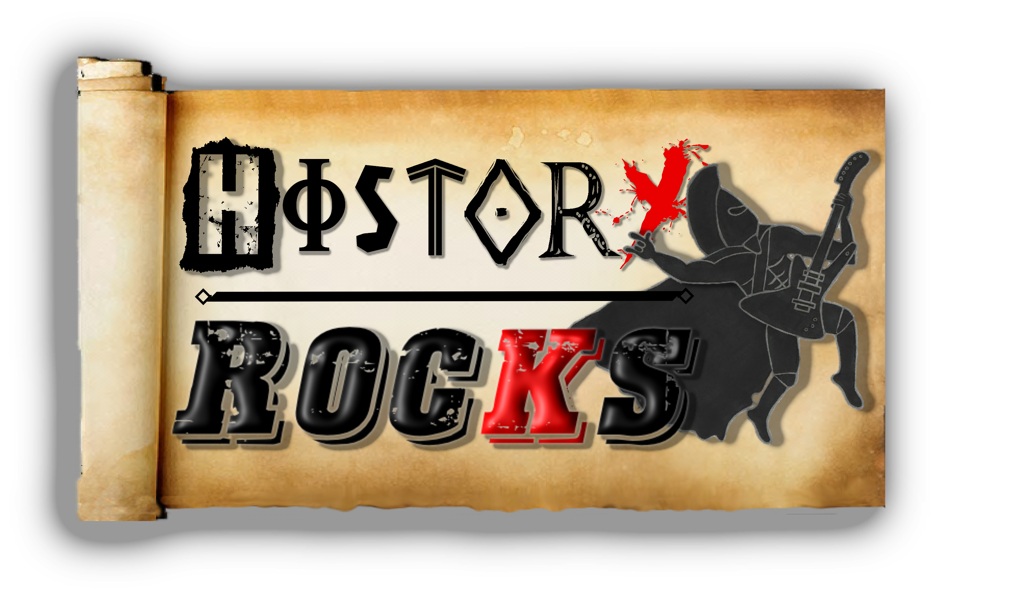
Scottish History – Here Come The Victorians
Queen Victoria makes a home
Balmoral Castle is where she goes

Glasgow’s built
It’s on a grid
It grows and disease
Then it hits
The poor and rich
They’re all at risk
Let’s think and do
Something quick

Oh – can you see it?
Refuse collection, it’s a start
Oh – can you see it?
Widening streets and parks

Chorus
Helped by growth of the Empire
Our country makes its name
Building ships for the traders
And mining coal all day

Oh – can you see it?
Ships sailing in the dock
Oh – can you see it?
Mining coal from the rocks

Chorus
Here come the Victorians
Holidaying in our lochs
Here come the Victorians
Fishing trout and shooting fox

Stretching over the country
Railways they start to grow
Connecting our major cities
And tourists start to go

Oh – can you see it?
Tracks in the countryside
Oh – can you see it?
Highlands and the wildlife

Chorus

