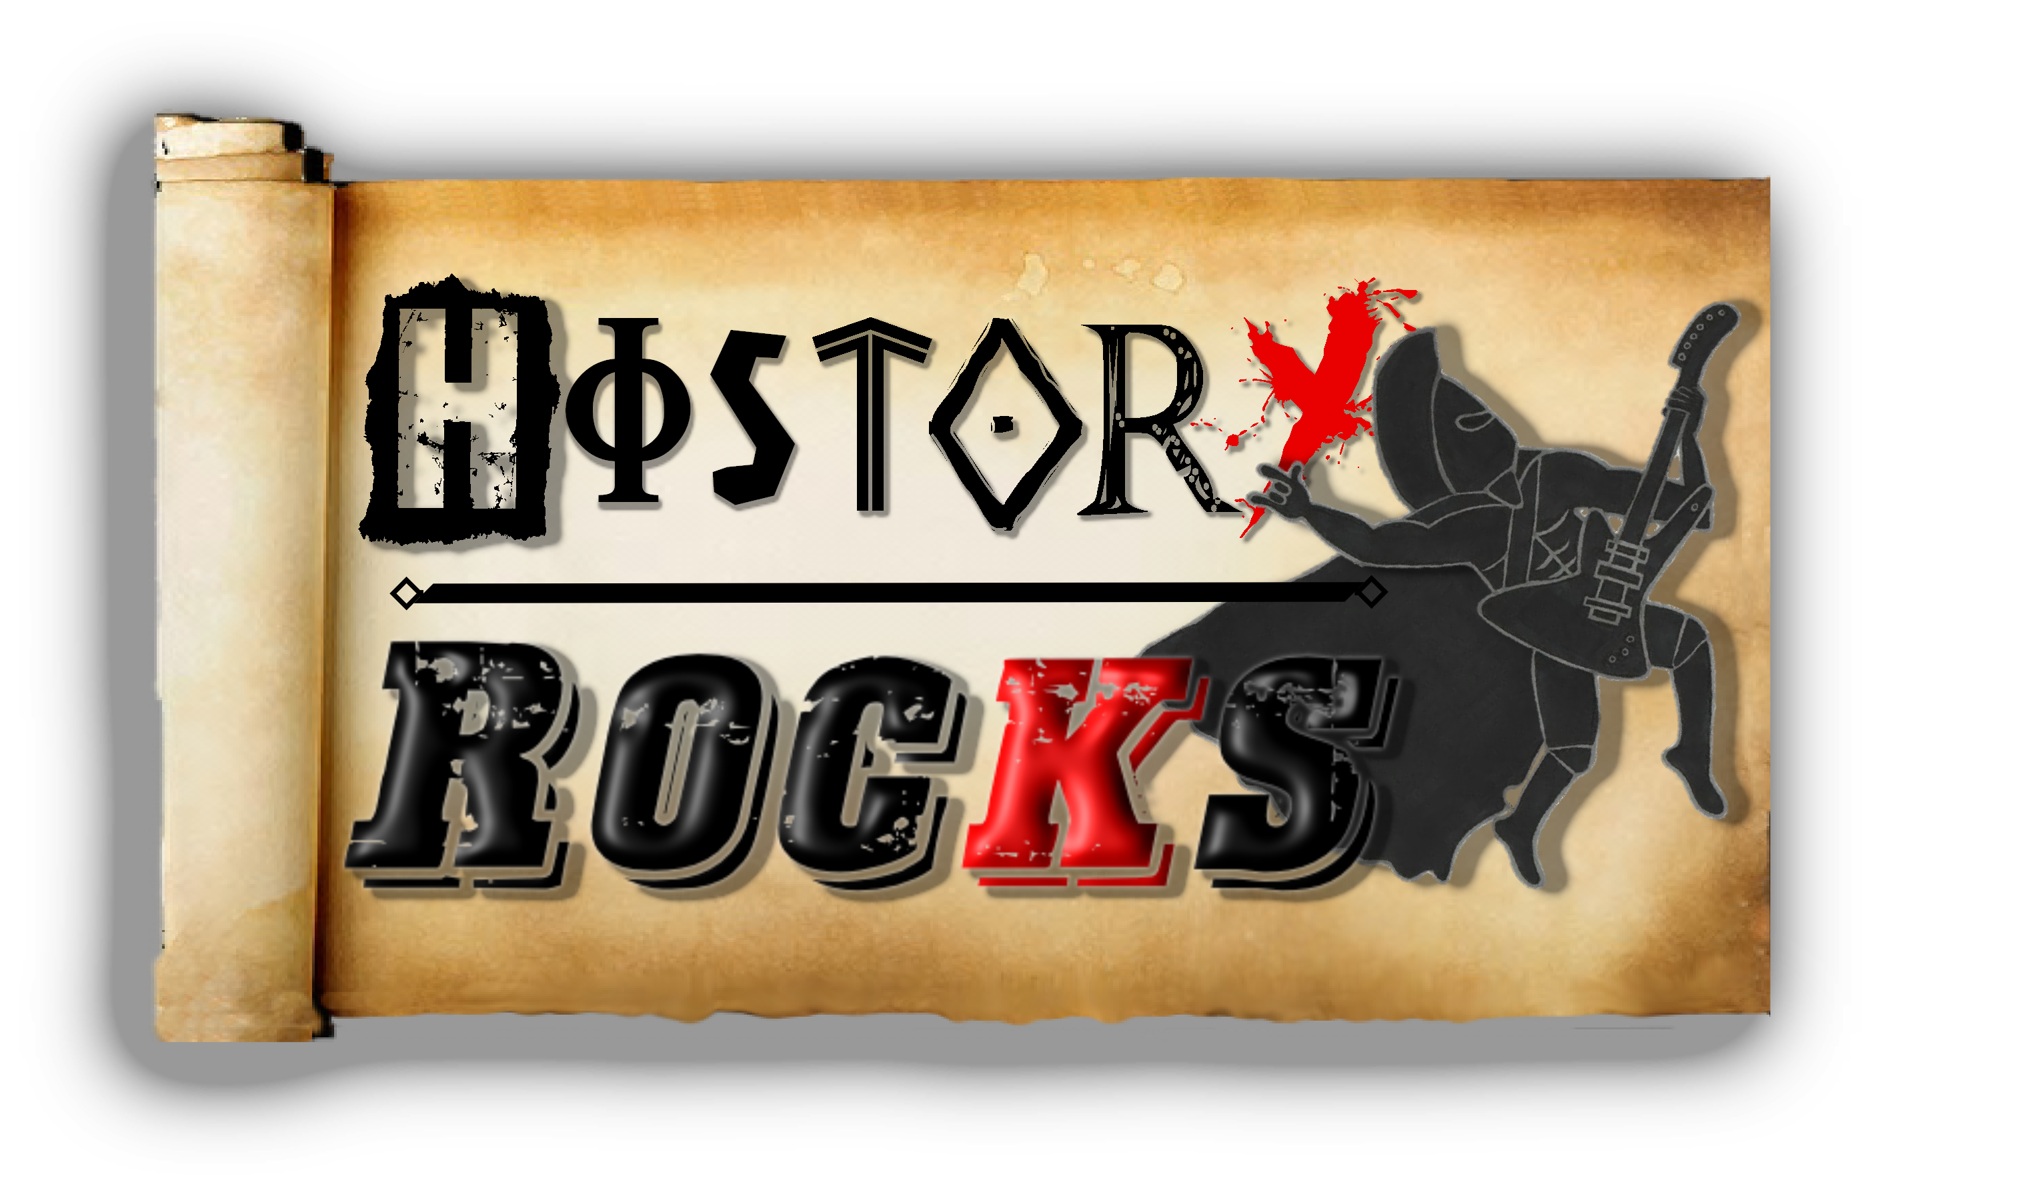**Viking Warriors!**

**The U S of A**

**Spain and Italy too**

**Africa, Britain**

**To name quite a few**

**Raiding the towns**

**Is how we got our fame**

**They call us Beserker**

**Our warrior name**

**Chorus**

**Fight against me**

**And you fight with my gods**

**They are our protectors**

**A formidable squad**

**Odin the King**

**He’s the top of them all**

**His ravens fly off**

**And say what they saw**

**A hammer of fire**

**A super strong belt**

**Thor loved his weapons**

**And power he felt**

**He battled the giants**

**He fought them and won**

**The Norse God of war**

**And Odin’s strong son**

**Chorus**

**Arrive on a boat**

**We’re the masters of sea**

**We built the longship**

**And we made a navy**

**We do what we want**

**And we do what we please**

**So hand over your gold**

**We’re the Vikings see**

**I’ll burn your crops and**

**I’ll plunder your homes**

**I’ll take my axe**

**And chop through your bones**

**After the battle**

**Valhalla awaits**

**I’ll sit with my brothers**

**And fill up our plates**

**Chorus**

**I’m a Viking warrior**

**If we get lost**

**We’ll always find our way home**

**A black feathered sat-nav**

**We follow the crow**

**We travel the world**

**And we conquer the seas**

**Pirating ships**

**And finding countries**

**That makes us Roman**