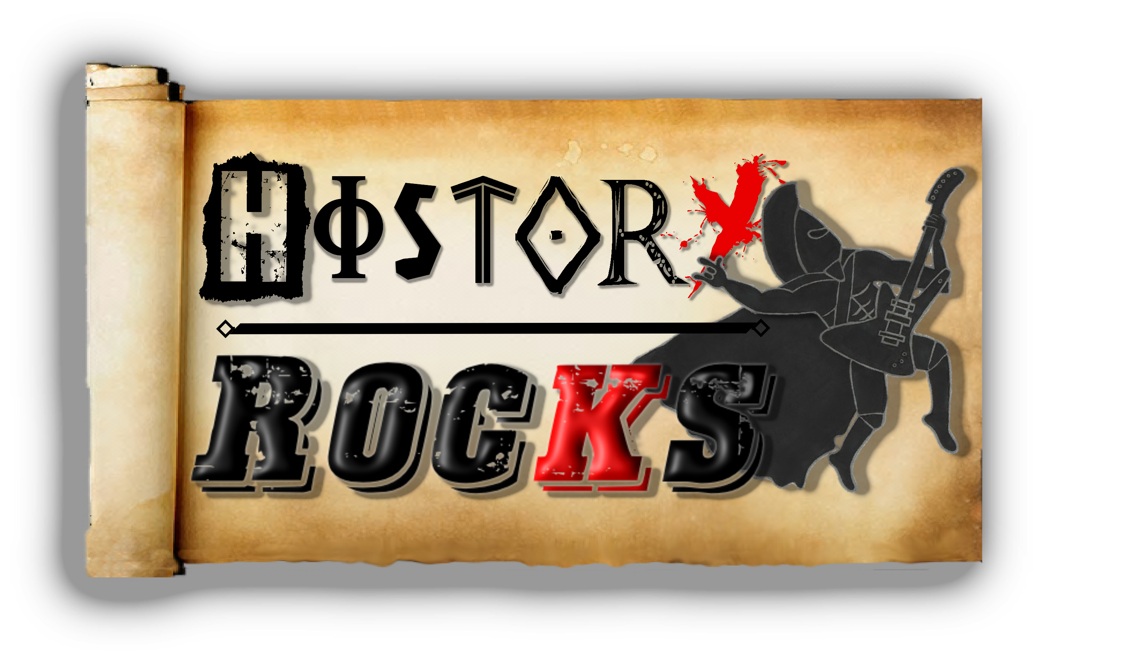**Science – The Digestive System**

**Chorus**

**What comes next?**

**This can't surely be the end?**

**What comes next?**

**This is where the food descends**

**Finally it's the large intestine**

**Collecting things we can't use**

**Reabsorbing water and**

**Getting rid of waste that we call poo!**

**Pre-chorus 1 (repeated)**

**Chorus (x4)**

**Chew your food, that's where it starts**

**You swallow it and the food departs**

**Into the oesophagus where it's squeezed**

**By muscles in the throat that push it free**

**Pre-chorus 1 (repeated towards the end of the song)**

**Food, it's on a journey**

**Travelling inside your torso**

**It's all kind of quirky**

**As you will start to know**

**But it's so important**

**To give us stuff to grow**

**Most of our vital organs**

**Play a part in this impressive show**

**Chorus**

**It's our digestive system (x2)**

**Then the food sits in your stomach**

**Like a giant food-filled bucket**

**Enzymes help to break it down**

**So the journey can continue to intestine-town**

**Pre-chorus 2**

**First up it's the small one**

**It's job's to break down food**

**And absorb nutrients**

**For our bodies to re-use**

**Liver helping greatly**

**Its bile is working too**

**Pancreas assisting**

**Enzymes that break down what you've chewed**