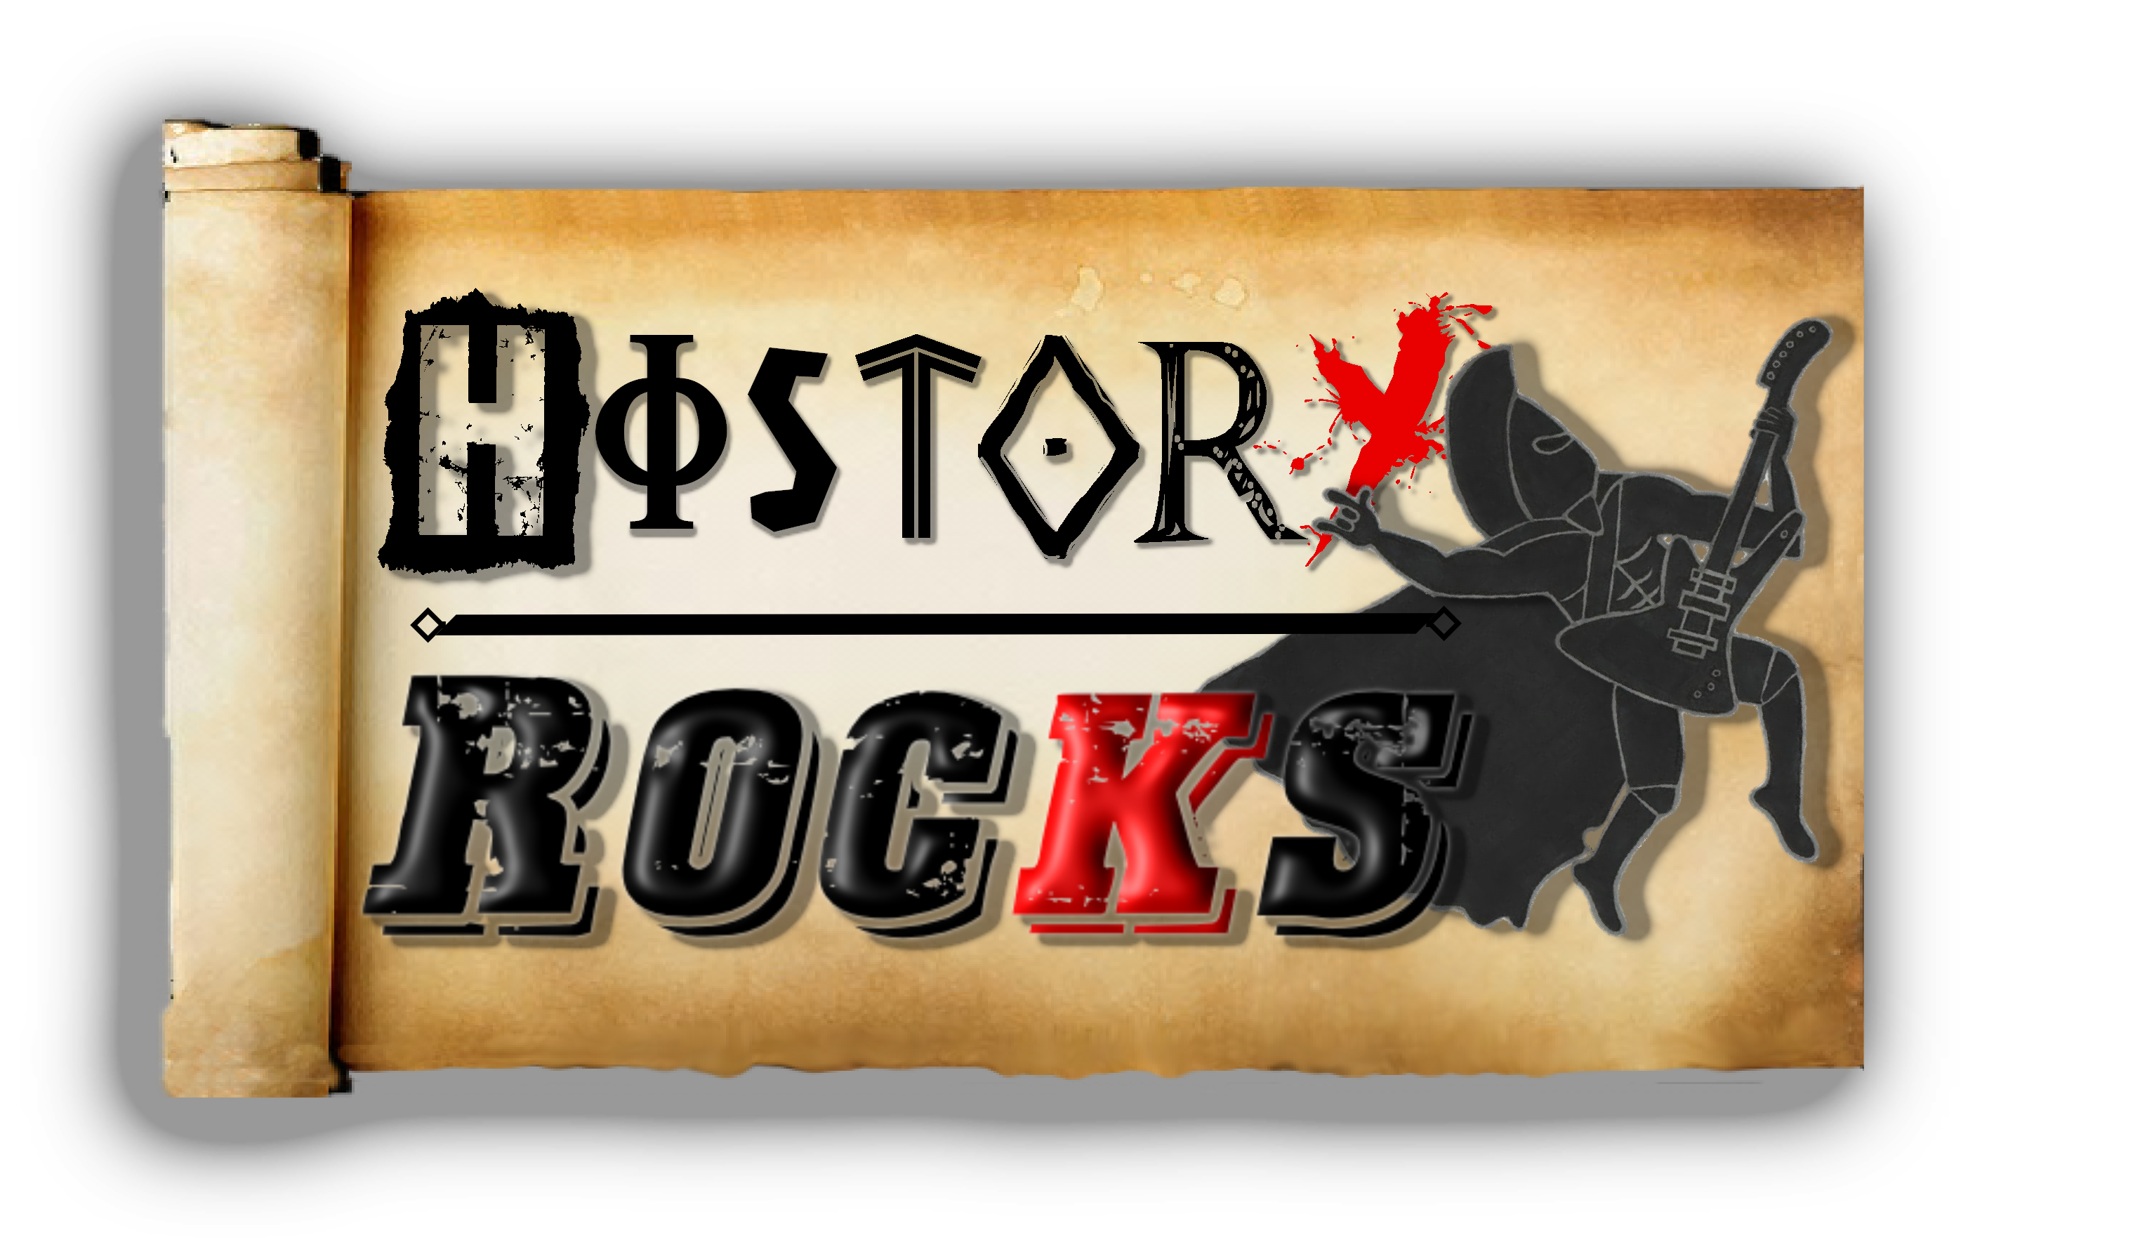**American History – The American Revolution**

**Looking for heroes**

**Paul Revere rides**

**The British are marching**

**And they're looking to fight**

**Washington's armies**

**Make redcoats retreat**

**We're kicking you out**

**So get moving your feet, ‘cos,**

**Chorus**

**Who would have known**

**When we thought to rebel**

**We'd make our own country**

**And beat the British as well**

**The date to remember’s**

**The 4th of July**

**It's our independence**

**For the states that unite**

**Chant: Hey, Hey, USA**

**Pushing the British**

**We're helped by the French**

**The redcoats surrender**

**Washington he accepts**

**War ending September**

**In late '83**

**Independence is signed**

**In a Paris treaty, so,**

**Chorus**

**We want our freedom**

**And we want you to go**

**The killings in Boston**

**A massacre so**

**We went to the harbour**

**And we boarded your boats**

**Threw you tea in the water**

**And we watched it all float**

**Representation**

**Is lacking for us**

**We want our rights**

**With no 'ifs' or 'buts'**

**Tiring of taxes**

**And demands for gold**

**We'll represent you with our boots**

**Get back on your boats, ‘cos,**

**Chorus**

**Hands off, this is America baby**

**It's the land and home of the free**

**Hands off, this is America baby**

**We don't need no foreign colony**

**We're meeting in Philly**

**In '74**

**We're sick of the British**

**And we're ready for war**

**We raised us an army**

**And by '76**

**Signed a Declaration Of**

**Independence**

**Chorus**