**Historical Pictionary!**

Players take it in turns to draw various objects, people or places from history and other players try to guess what it is that has been drawn.

Best played in teams, each team has to guess correctly to win a point. Teams could stay on if they guess correctly, or alternate turns could be taken. A time limit could be set or a maximum number of points could be reached. Alternatively, each team could start with a set number of points and has to be the first team to reach zero.

Players can choose to draw whatever they want but may use the provided cards if they are struggling to think of something that they can draw themselves. The 'Hint’ should help make the drawing simpler if they think the picture example is too hard. This is just to give them a simpler, visual representation of the object.

Players should try to guess the time period too, rather than just the drawing. Extra points could be awarded for guessing the correct time period.

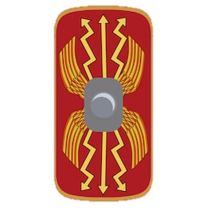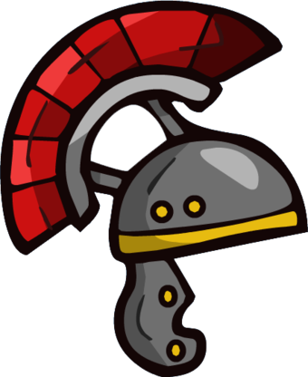

**Hint**

Draw a semi-circle for the head part, then an arch on top for the red plume part and place some lines in the middle of the arch to show that it’s hair.

**Roman Shield**

**Roman Helmet**

**Hint**

Draw a rectangle with slightly rounded edges. Then draw a circle in the middle and a small rectangle around it with some wavy lines coming from the rectangle in the middle

**Hint**

Draw a circle for the head, then draw a triangle on either side of the head. Give it a rectangular body and then some rectangles for fingers.

**Egyptian Pyramids**

**Hint**

Draw 3 triangles and start to give them lines going across and down to make them look like bricks.

**Egyptian Sphinx**

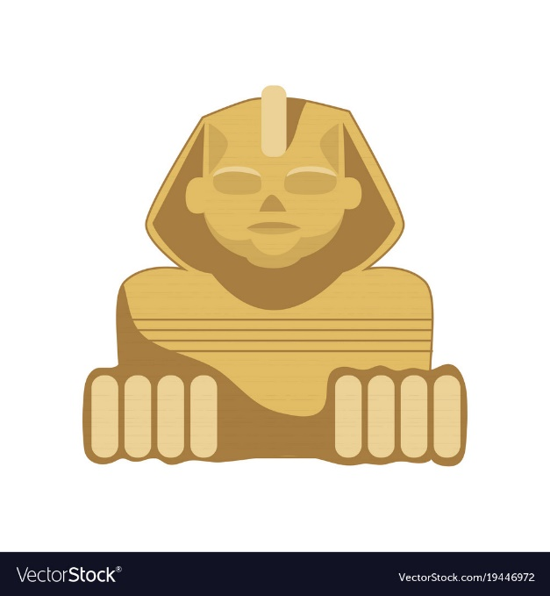

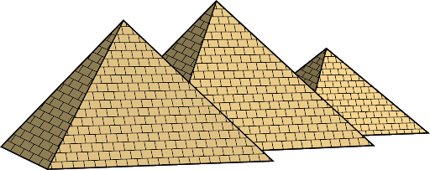

**Viking Longboat**

**Hint**

Draw a rectangle for the boat. Add on an S to one end of the boat and a backwards S to the other. Then draw a line with a triangle on going up from the middle for the sail.

**Viking Battle Axe**

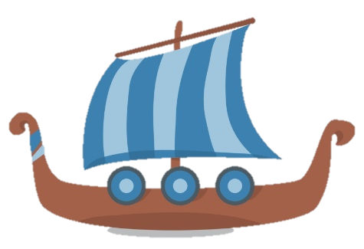

**Hint**

Draw a long, thin rectangle for the body. If you are struggling with the metal head part, draw a triangle with the point touching the rectangular body.

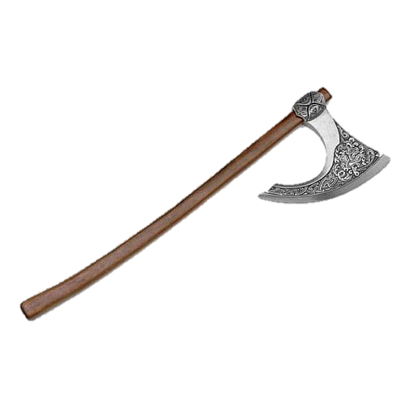

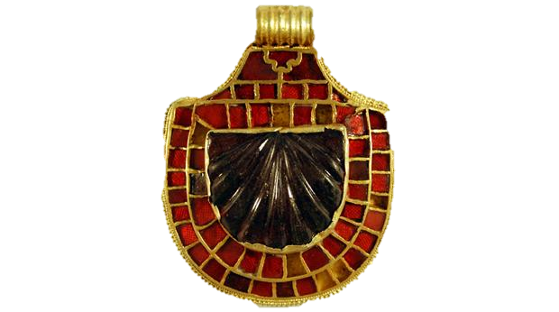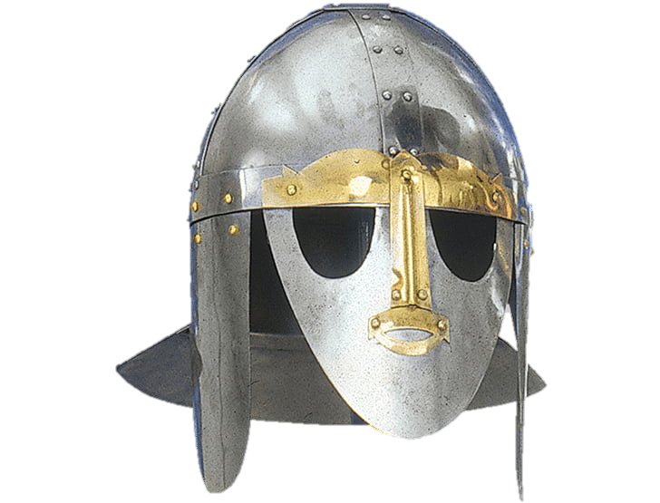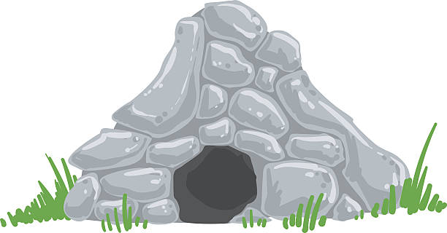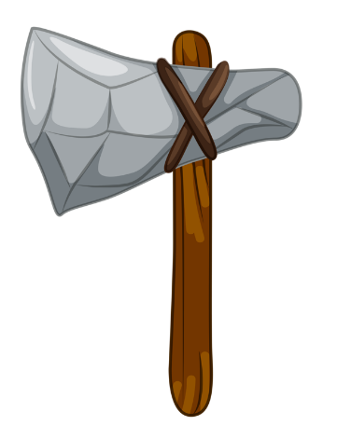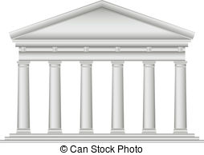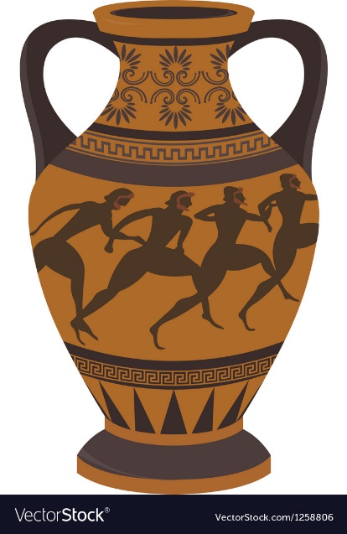

**Hint**

Draw a semi-circle for the main body part, with a smaller one in the middle. Then add lots of lines to make it look like the smaller stones. Add a small rectangle to the top.

**Hint**

Draw a semi-circle for the top. After that, draw a longer, slightly thinner semi-circle underneath for the face part. Then 2 small semi-circles for the eyes and then draw the mouth and moustache.

**Anglo-Saxon Jewellery**

**Sutton Hoo mask**

**Hint**

Draw a circle in the middle and colour it in. Then draw round and odd-shaped stones around the circle to make it look like a cave.

**Stone Age Tool**

**Hint**

Draw a long thin rectangle for the handle, then the stone head. Add a few lines to show that it’s stone and then an X show the string holding it together.

**Stone Age Cave**

**Hint**

Draw a triangle for the roof, a rectangle underneath the roof and then long, thin rectangles for the columns.

**Hint**

Draw the outline of the vase and add on two handles at the sides near the top. Then draw some stick people running or fighting on the vase.

**Greek Vase**

**Greek Temple**

**Maya temple**

**Hint**

Draw a few rectangles on top of each other, with them getting narrower towards the top. Then draw a rectangle in the middle of them going from top to bottom.

**Maya cacao bean**

**Hint**

Draw the bean shape first and then add leaves on afterwards. Add some wavy lines onto the bean to help show what it is.

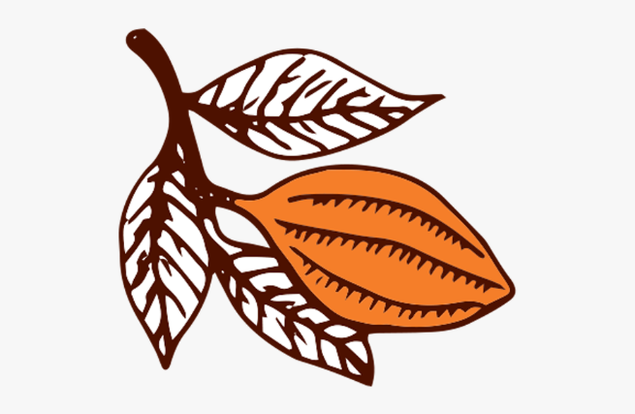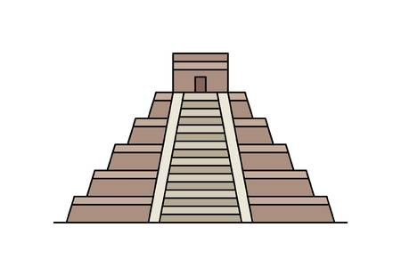

**WWI trench**

**Hint**

Draw a U shape with a little step on one side. Then add some small rectangles at the top for sandbags and some curls next to them for barbed wire.

**WWI gas mask**

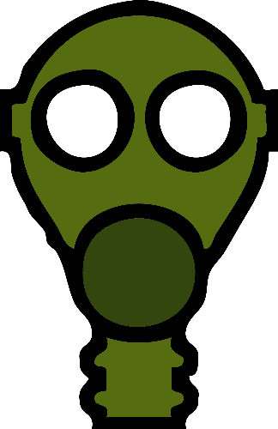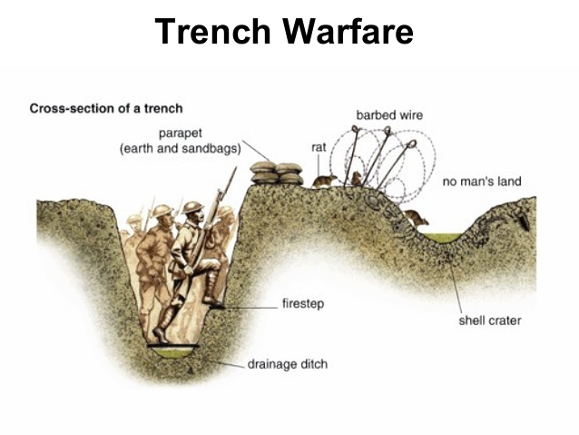

**Hint**

Draw the outline of the mask like the shape of a head. Then add a big circle where the mouth should go for the filter, then the tube going down. Finally, add two eye holes.

**Hint**

Draw a rectangle for the body but make it thinner at the bottom. Add the wings onto the sides, then add the tail at the bottom. Then add the circles onto the edges of the wings.

**WWII tank (American Sherman tank)**

**WWII Plane (British Spitfire)**

**Hint**

Draw a rectangle for the body of the tank with a smaller rectangle on top of it. Draw another rectangle coming out of the top for the barrel of the tank. Add circles on the bottom for the wheels and a line around them for the tracks.

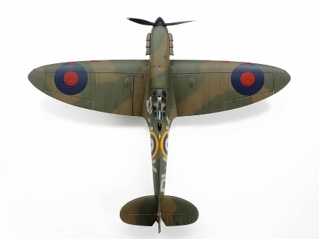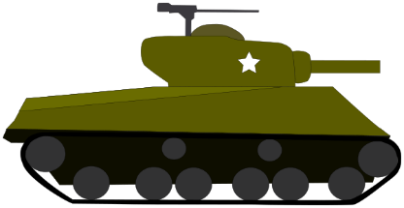

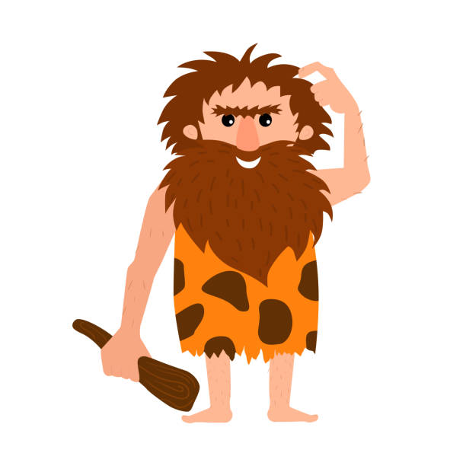

**Hint**

Draw a head and a body, but make the bottom of the body a bit spikey like ripped clothes. Give the head lots of hair and a beard. Draw some arms and give one of them a club.

**Greek philosopher/thinker**

**Cleopatra (Egyptian Queen)**

**Hint**

Draw the golden headdress first, then draw a semi-circle for the top part of the hair. Add the longer bits on to the sides and then draw the face. Draw the ears and add earrings and jewellery too.

**Stone Age man**

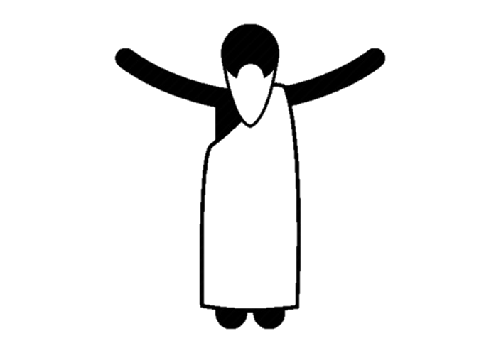

**Hint**

Draw a triangle for the beard, then add a semi-circle on top for the head. Draw the cloth and add two semi-circles at the bottom for feet. Make the body a bit thinner than the cloth and have arms pointing upwards.

