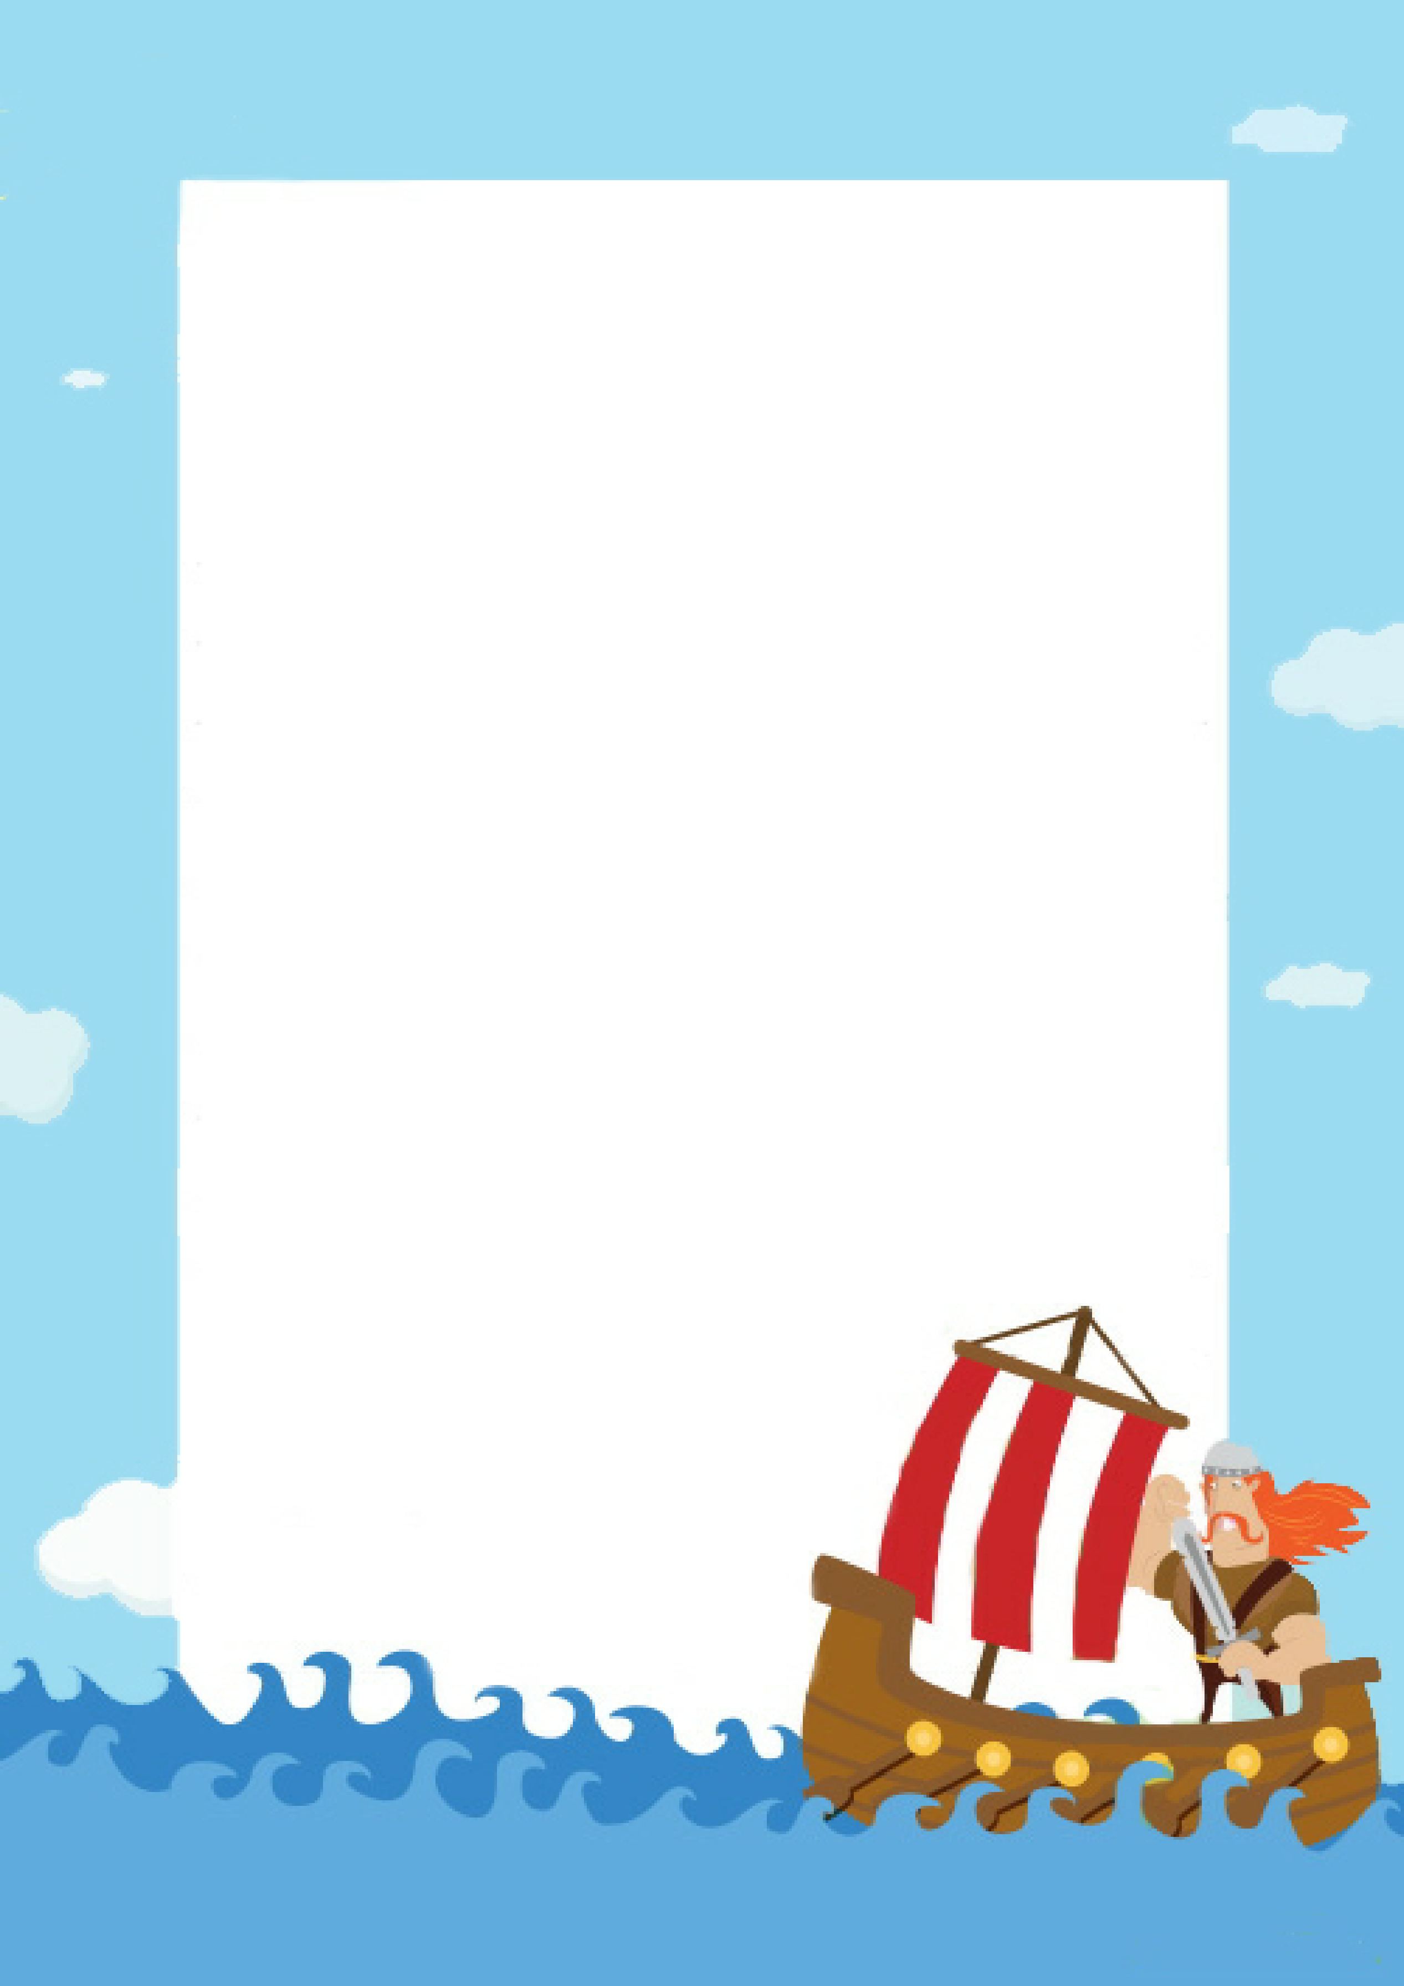

**Find and then scan the QR codes to write down the answer to each question. The first letter of each Red answer will give you a word. When you have collected all of the answers, answer the black questions for bonus points!**

**Viking QR Trail**

1. **What were the items that some Vikings were buried with known as?**

**What might rich Vikings be buried with?**

1. **Which city did the Vikings capture in 866?**

**How many people might have lived in Jorvik?**



1. **Which country did Erik the Red discover?**

**Why did he call it that?**

1. **Name the place where the Viking gods lived:**

**Why did Odin only have one eye?**

1. **What did the Vikings invent to help them navigate?**

**Name 3 things the Vikings traded:**

1. **What were straw, wool and moss used as a form of?**

**Which animals often lived in the house?**

**9. Name the minor trickster god:**

**Which religion did some Vikings convert to?**

**4. What were Viking Longships sometimes referred to as?**

**Why did they have creature’s heads on the front?**

1. **Which ‘r’ did the Vikings carve onto their shields?**

**What was the special class of warrior called?**

The word to find is: is:

Insulation

**Find and then scan the QR codes to write down the answer to each question. The first letter of each Red answer will give you a word. When you have collected all of the answers, answer the black questions for bonus points!**

Berserker

To protect them from sea monsters and frighten the enemy

To get people to stay even though it was just ice!

**Silver, silk, spices, wine, jewellery, glass and pottery**

Yggdrasil (igg-dra-sil)

(The world tree)

Asgard

York

Grave goods

Runes

Christianity

Loki

Sheep, goats and cows

Sun compass

He traded it for all of the wisdom in the world

Dragon ships

Greenland

A ship

15,000

The word to find is: is:

**9. Name the minor trickster god:**

**Which religion did some Vikings convert to?**

**4. What were Viking Longships sometimes referred to as?**

**Why did they have creature’s heads on the front?**

1. **What were Straw, wool and moss used as a form of?**

**Which animals often lived in the house?**

1. **What did the Vikings invent to help them navigate?**

**Name 3 things the Vikings traded:**

1. **Name the place where the Viking gods lived:**

**Why did Odin only have one eye?**

1. **Which ‘r’ did the Vikings carve onto their shields?**

**What was the special class of warrior called?**

1. **Which country did Erik the Red discover?**

**Why did he call it that?**

1. **What were the items that some Vikings were buried with known as?**

**What might rich Vikings be buried with?**

1. **Which city did the Vikings capture in 866?**

**How many people might have lived in Jorvik?**

**Viking QR Trail**