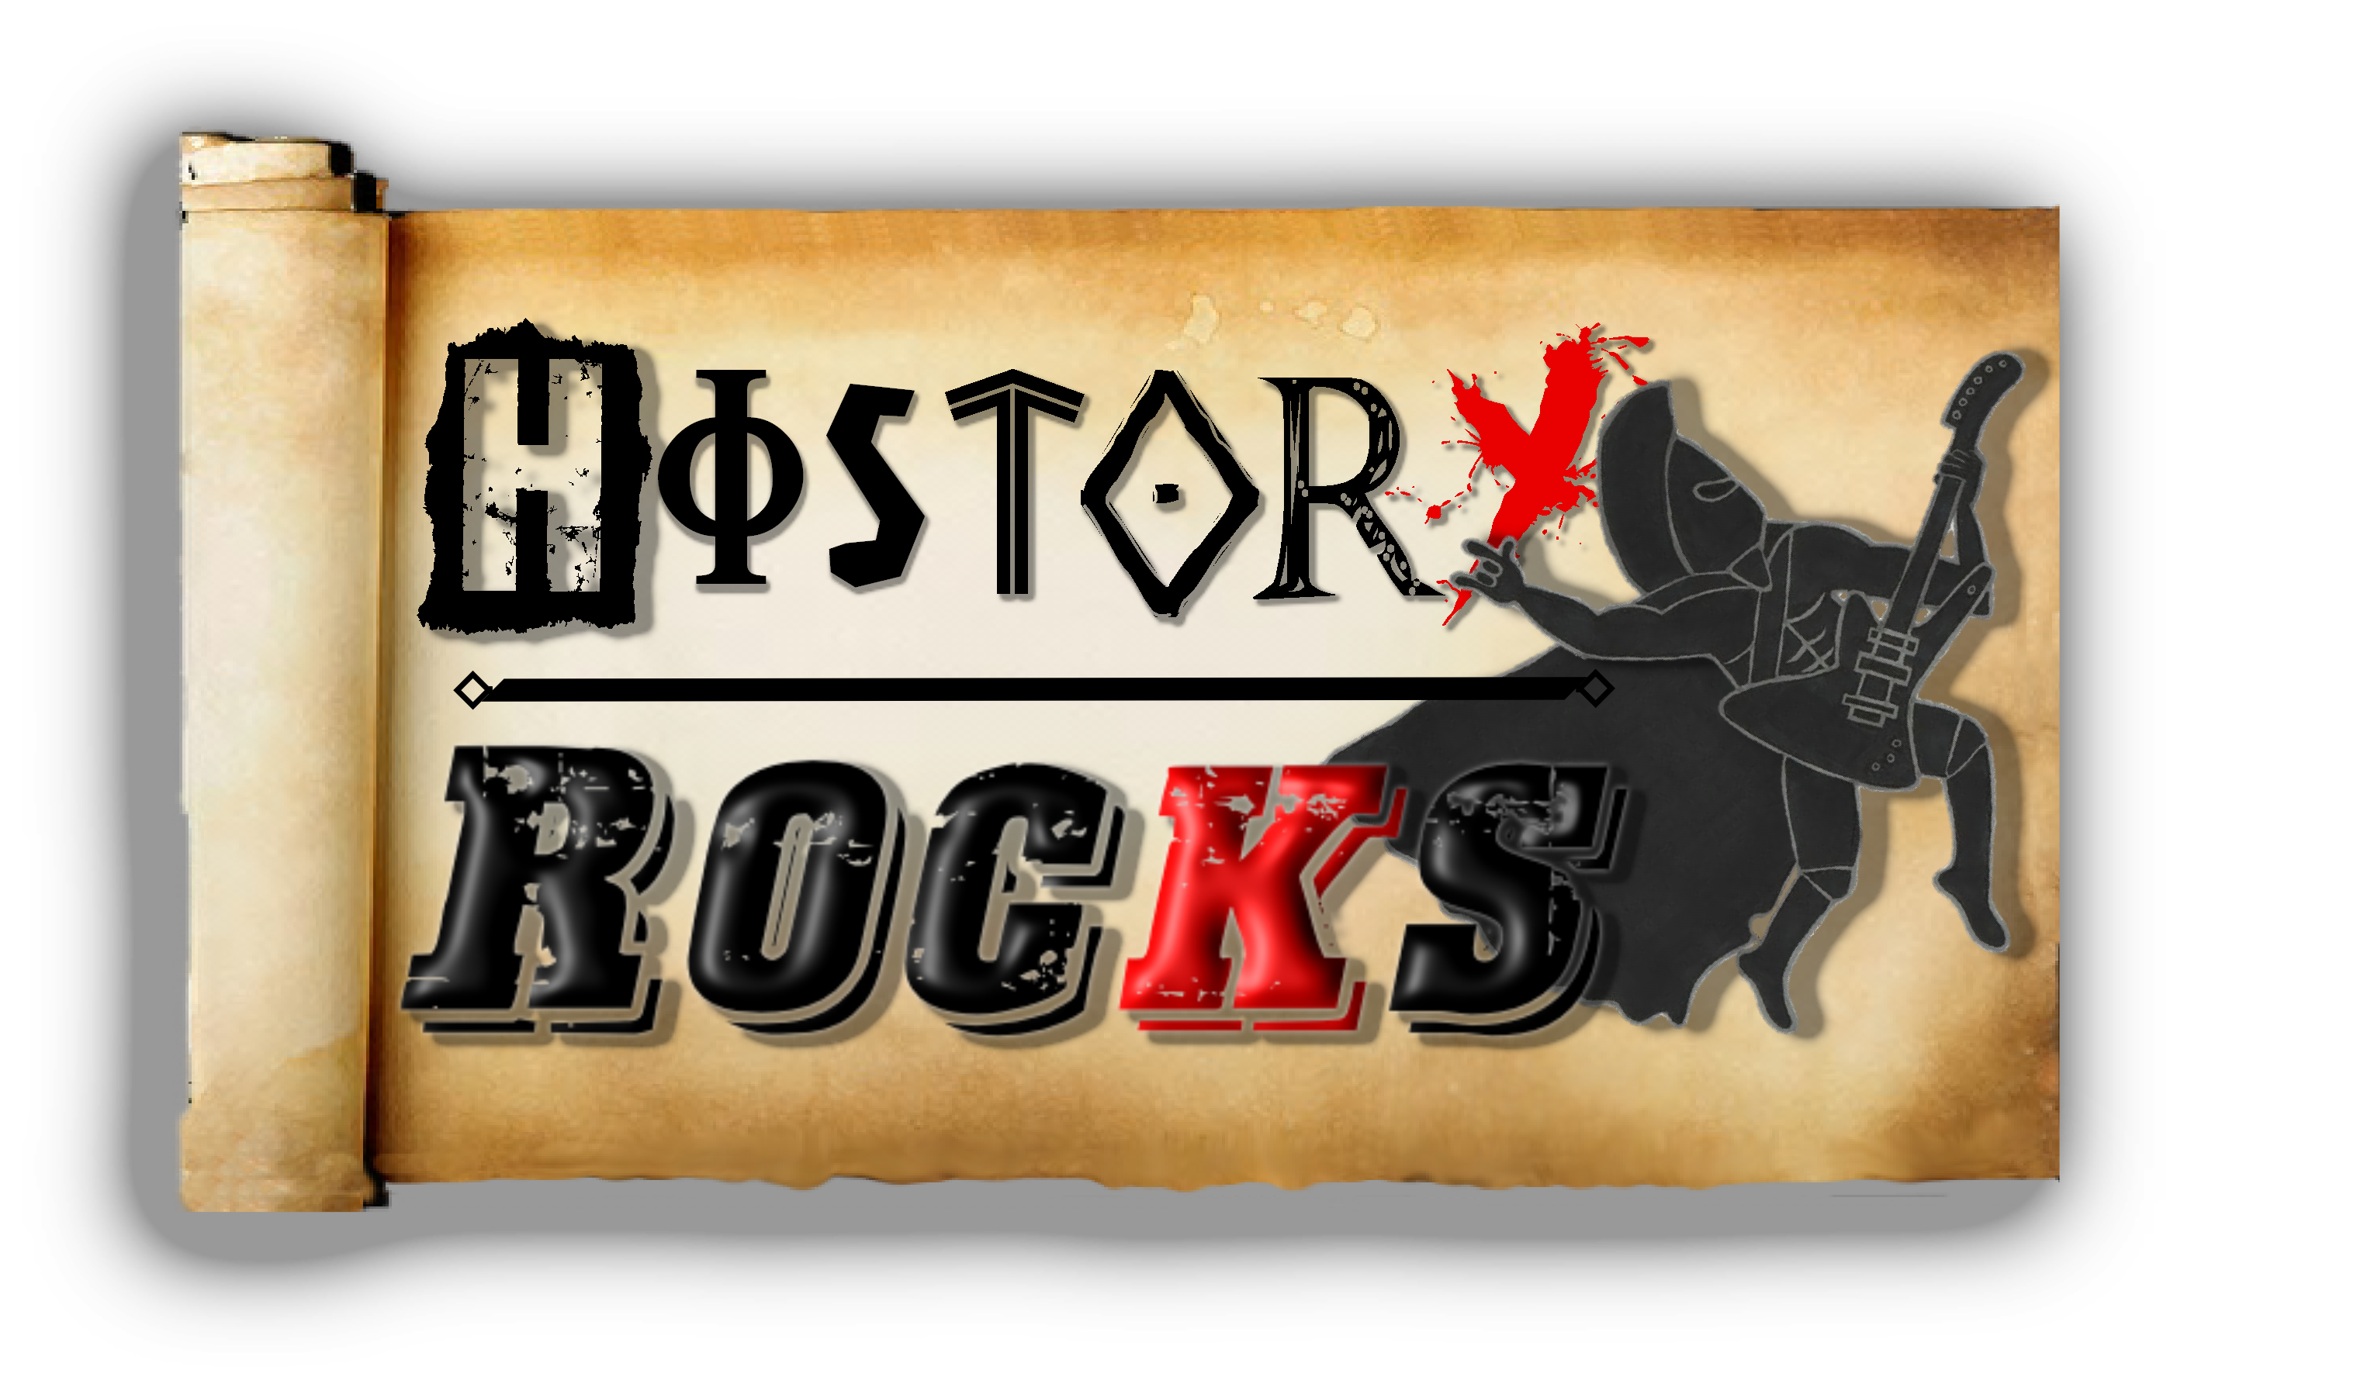**Geography – African Animals**

**Lying in the grass**

**I'm scoping out my prey**

**I can see gazelles**

**And hippos play**

**Spying from the edge**

**I see the buffalo**

**Think they're safe**

**But they don't know that...**

**I'm getting hungry**

**What can I eat?**

**An antelope? A zebra?**

**Or a wildebeest?**

**I'm getting hungry**

**What can I eat?**

**Soft and chewy, red and mucky**

**How about a meat feast?**

**Chorus**

**I am the King, I am the King of Africa**

**Don't even think, of someone else 'cos you'd be wrong**

**I am the King, I am the King of Africa**

**And my offspring, will take over when I'm gone**

**Hiding in the trees**

**Above the dusty floor**

**I can hear baboons**

**And gorillas snore**

**Over by the side**

**Of the water hole**

**Sit the springbok**

**And the rhino**

**I'm getting hungry**

**What can I eat?**

**An elephant or camel?**

**Or a tasty treat?**

**I'm getting hungry**

**What can I eat?**

**Soft and chewy, red and mucky**

**How about a meat feast?**

**Chorus**

**I am the King of Africa**

**Don't forget it, it's my name**

**Razor teeth and gorgeous mane**

**Strength in numbers, hear me roar**

**I'm the king and that's for sure**

**I'm getting hungry**

**What can I eat?**

**A crocodile? A python?**

**Or something sweet?**

**I'm getting hungry**

**What can I eat?**

**Soft and chewy, red and mucky**

**How about a meat feast?**

**Chorus**