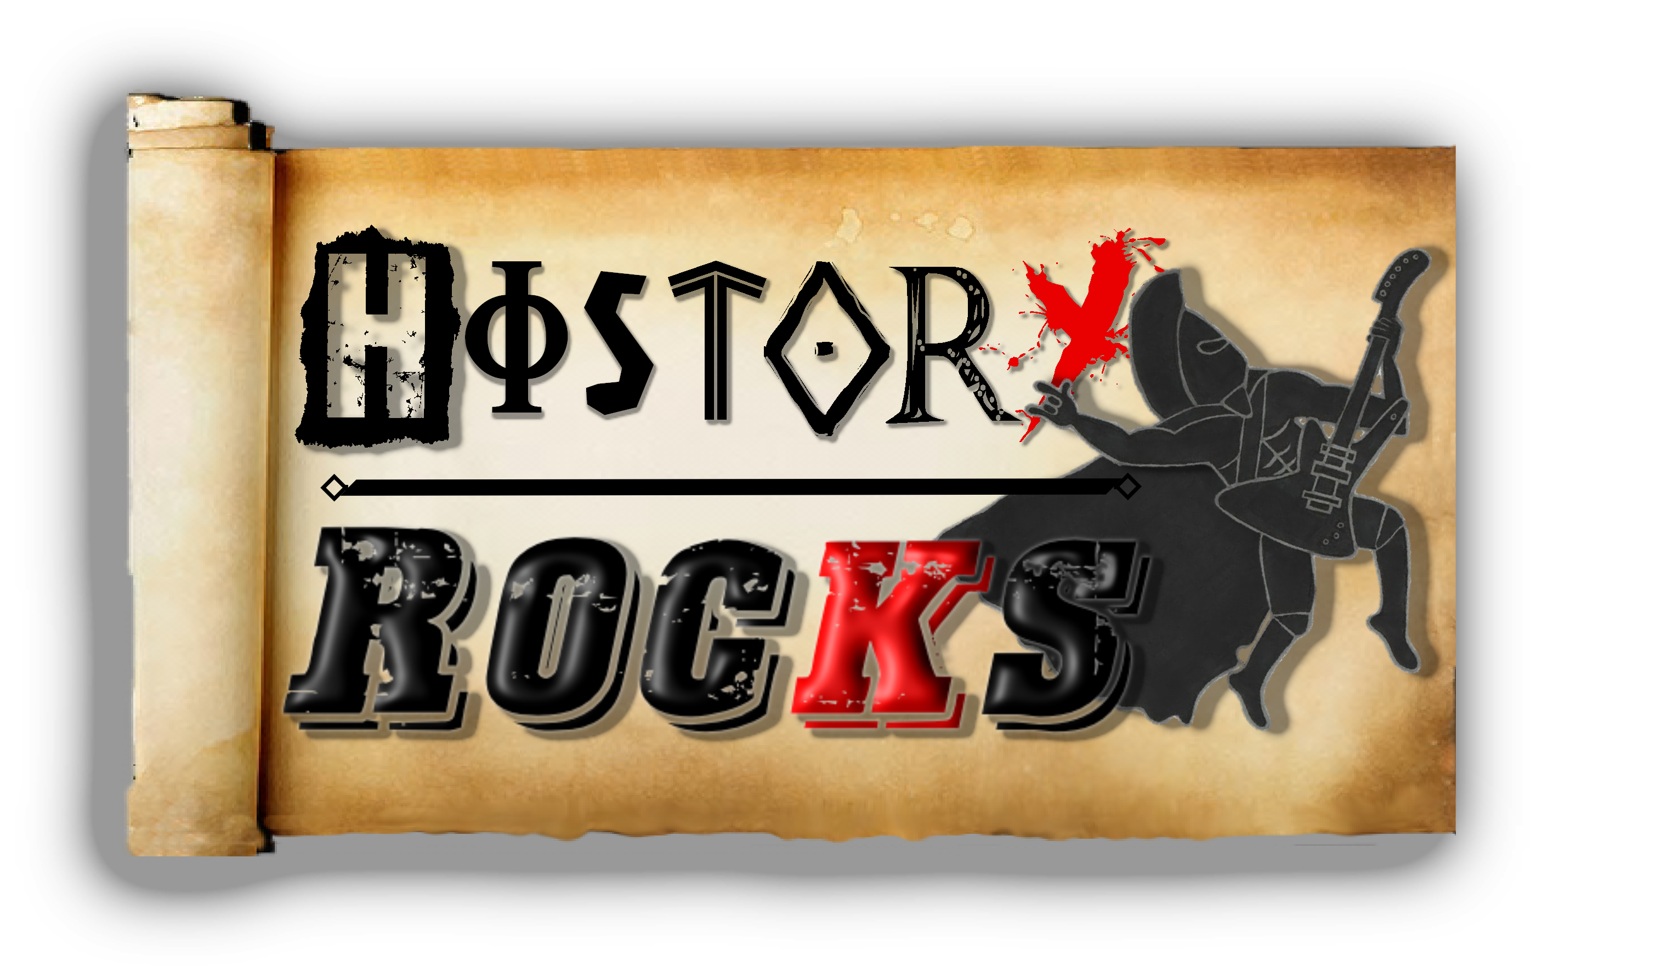**Stone Age – Paintings**

**Stories, stories**

**We do tell**

**Over the cliffs**

**The animals fell**

**Here is a fact**

**That’s just for fun**

**There were hippos**

**Living in Stockton**

**Hippos in town**

**Now extinct**

**Only on the TV**

**Chorus**

**Paintings, paintings**

**On the wall**

**We use these**

**So we can talk**

**Telling all the cavemen**

**About our lives**

**About our homes**

**Our kids and wives**

**Go do this**

**Go do that**

**Nag, nag, nag**

**Chorus**

**Paintings, paintings**

**On the wall**

**Colourful, exciting**

**We can draw**

**Buffalo, tigers**

**And a horse**

**These are caveman**

**Drawings of course**

**Paintings, paintings**

**I can see**

**Reds and browns**

**And orange and greens**

**Crayons on the cave wall**

**Painting with a stick**

**Telling our stories**

**Tiger runs quick**

**Tiger runs quick**

**Mammoth runs slow**

**Bear gets big**

**Chorus**

**Painting on the cave**

**Painting on the floor**

**Painting all the animals**

**Let’s paint some more**